# 1114 Processing In Transit Disbursements

Semester Group Project



## Team Members:

* Alejandro Porrata
* Nevin Wilson
* Jordan Richards
* Asim Umar
* Samuel Kim
* Jalen Coulton
* Natalie Ramdeo
* Samuel Kim

# Individual Contributions:

## Project Contribution to Team Work Product (1 of 4)

* Alejandro Porrata:
  + Organized group collaboration (Zoom Meetings/Scheduling)
    - Zoom meets: 3/20/24, 3/22/24, and 3/23/24 (2 hour sessions)
  + Identified questions upon first read-through of the document
  + Helped diagram cross-center I disbursements
  + Asked questions after the presentation
* Jordan Richards:
  + Helped diagram in-center disbursements
  + Set up the lucid chart
  + Helped identify questions for decision boxes
  + Presented Teamwork Product (1 of 4)
  + Followed up with questions
* Jalen Coulton:
  + Helped identify potential questions from the document
  + Assisted in the making of the process flow chart
* Nevin Wilson:
  + Helped with setting up the doc for brainstorming with the overall flow chart and conditions.
  + Assisted in the process of setting up the chart following the document and policies.
* Asim: I was responsible for proofreading the lucid chart
* Natalie Ramdeo:
  + Attended the group collaborations (zoom meetings)
    - Dates: 3/20/24, 3/22/24, and 3/23/24
  + Helped identify some questions during the read-through.
  + Did some edits with the Lucidchart diagram.

## Project Contribution to Team Work Product (2 of 4)

* Alejandro Porrata:
  + Organized group collaboration (Friday 3/29- 3.5-hour Zoom meeting).
  + Reworked the first half of our diagram before the meeting to get us started.
  + Set up a new LucidChart for everyone to collaborate on V2 of the chart.
  + The following week after class identifying controls was assigned. I reworked the flowchart to make a high-level template for V3 of the chart
  + Identified 6 controls.
  + I set up a Zoom meeting on Friday 4/5- to discuss identified controls, and cleaned up the V3 template, and finalize the version with my attending group members.
* Jordan Richards:
  + Cross-referenced the previous diagram with the new one to identify questions we could reuse.
  + Worked on Cross Disbursement and Within Center disbursement categories and unified both into a single process that connects to the right hand of the diagram.
* Jalen Coulton:
  + Helped work on questions with Jordan and helped format the diagram into a readable format
  + Helped with the front and capitalization during the zoom meet
* Nevin Wilson:
  + Helped with font and capitalization
  + Helped with proofreading the diagram and making necessary changes
* Natalie:
  + Helped with font and capitalization during Zoom meet
  + On April 5th, I helped with the list of controls.
* Asim:
  + Helped with font and capitalization during Zoom meet
  + Insured that all the controls were there and proofread and adjusted and edited

Any new controls depending on the needs of the diagram.

* + Furthermore ensured right controls are presented in the chart.
  + Worked on the title page for the group project.

* Samuel Kim:
  + Inserted Version 3 of Diagram into journal
  + Adjusted the diagram
  + Proofed the diagram and pointed out some issues
  + Imported established vocabulary to data dictionary

## 

## 

## Project Contribution to Team Work Product (3 of 4)

* Alejandro Porrata:
  + Set up the Zoom meeting on Friday 4/19 @6pm
  + Helped the group create a flowchart unifying the controls established last week for in-transit disbursements
  + Identified Entities and Attributes for enhanced documentation review for data mapping
  + Will present unified control during class
* Jordan Richards:
  + Created Lucidchart for the group to unify controls and begin data mapping
  + Actively engaged in the Zoom meeting discussion, and contributed to the formulation of 1114’s unified control
  + Data mapped within the center and cross-center tagging control
* Jalen Coulton:
  + Creating flowchart for Fraud Detection Mechimism
  + Helped unify all controls into one
* Nevin Wilson:
  + Worked on control *Compliance Tracking* with all team members present and brain stormed through the process
  + Helped with font, capitalization, and mapping
  + Worked on setting up the ERD
* Natalie Ramdeo:
  + Attended Zoom meeting on 4/19
  + Helped with unifying the controls that were created last week.
* Asim: Attended Zoom meeting on 4/19
* Completed my controls on the lucid chard and help the team in unifying all other controls

Also worked on data mining and mapping

-Samuel Kim:

-Attended zoom meeting assisted working on the unifying the controls

-also worked on MFA flow chart which we found was not able to be incorporated into our project

## 

## Project Contribution to Team Work Product (4 of 4)

* Alejandro Porrata:
  + Helped refine controls and updated the unifying control chart
  + Set up the Zoom meeting to work on controls
  + Updated Lab Notebook to include Data Model
  + Established a data model for the enhanced documentation review control
* Jordan Richards:
  + Established entire tagging control data mode
  + Made a revised version of Cross center/Within center tagging
  + Helped the group work through their controls.
  + Rearranged the final Lucid Chart to be more accurate.
* Jalen Coulton:
  + Added Fraud detection control to the data model connecting it to the the enhanced documentation control.
  + Refined fraud detection control
* Nevin Wilson:
  + Helped with modifying attributes and entities on LucidChart
  + Refined Compliance Tracking control
* Asim: refined and updated the UMD/ NULO controls
* Created tables identified the entities and attributes for each table in the
* Natalie:
  + Made adjustments to my control diagram to expand upon it.
  + Created a few entities based on the control diagram and connected them to the overall data model
* Samuel Kim:
  + Assisted with looking at final controls and see what could be fixed
  + Attended the zoom meeting

# Narrative

* **Start**: The process begins with determining if a disbursement made by the disbursing office has been reported and charged against the Department's fund balances to the Treasury but is not received by the accounting office, received but not processed, or lacks sufficient information for processing.
* **Disbursement Status**: If the disbursement is in transit, it's checked whether it has been routed to the correct accounting office and if detailed supporting documentation has been provided. If documentation is insufficient, a request for additional information is made.
* **Processing Decisions**:
  + If the accounting office has enough information, it attempts to process the in-transit disbursement.
  + If additional information has been requested and not provided, or if appropriate action has not been taken, the process evaluates if the transaction is fraudulent or under suspicion.
* **Transaction Handling**:
  + Transactions identified as fraudulent are rejected.
  + Transactions under $2500 are treated as UMD (Unmatched Disbursements).
  + If the disbursing and accounting offices report to the same DFAS center, the disbursement is processed within the center; otherwise, it's cross-center.
* **Suspension and Transmission**:
  + Disbursements may be suspended unless submitted for payment properly.
  + If disbursements are properly transmitted to the accounting center, and sufficient information is provided, they are processed.
* **Request and Rejection**:
  + If the disbursing office or entitlement activity has not sent the requested information within 30 days, the payment center requests information or rejects the in-transit disbursement.
* **Final Processing**:
  + The flowchart also details scenarios where transactions are rejected back to the accounting center or disbursing office for lack of information or accountability.
  + If the accounting office can establish accountability for the disbursement, it processes the transaction. Otherwise, it requests the correct information.
  + Finally, if sufficient information is provided, the disbursement is processed; otherwise, it's rejected or recorded as UMD based on specific criteria.
* **End**: The process ends when the disbursement is either processed successfully, rejected, or recorded as a UMD or NULO (Not Used Lose Obligation), depending on the scenario.

# Established Vocabulary:

* **In-Transit Disbursements**: Disbursements are considered in-transit disbursements when they have been reported by the disbursing office, through a paying center, to the Department of the Treasury and charged against the Department’s fund balances, but: (1) have not yet been received by the applicable accounting office, (2) have been received by the applicable accounting office but not yet processed against (attempted to be entered into) the accounting office’s database, or (3) it has been determined that there is insufficient information to process. The policy guidance that follows specifically addresses in-transit disbursement transactions. This policy encompasses all in-transit disbursements, including inter-fund transactions and disbursements originating outside the DoD
* **Disbursement**: For purposes of matching a disbursement to its proper obligation, the term disbursement as used in this chapter refers to the amount charged to a separate line of accounting. While a single payment may be charged to multiple lines of accounting, for purposes of matching a disbursement to its proper obligation as addressed in this chapter, each amount charged to a separate line of accounting is treated as a separate disbursement and must be matched to its corresponding obligation
* **Fund Holder**: An individual holding an administrative subdivision of funds or an operating target, who is responsible for incurring obligations against the administrative subdivision or target and for managing the use of such funds
* **Unresolved Disbursement**: An unresolved in-transit disbursement occurs when a disbursement is not matched to the correct obligation because either: (1) it cannot be, or has not been, routed to the correct accounting office, or (2) the accounting office does not have sufficient information to allow it to attempt to process the in-transit disbursement.
* **Obligation**: For purposes of matching a disbursement to its proper obligation, as addressed in this chapter, the term obligation refers to each separate obligation amount identified by a separate line of accounting. While a single order may be funded by multiple lines of accounting, for purposes of matching a disbursement to its proper obligation, as addressed in this chapter, each line of accounting represents a separate obligation amount to which the resulting disbursement must be matched. Obligations are defined as amounts of orders placed, contracts awarded, services received, and similar transactions during an accounting period that will require payment during the same, or a future, period. Such amounts include payments for which obligations previously have not been recorded and adjustments for differences between obligations previously recorded and actual payments to liquidate those obligations. The amount of obligations incurred is segregated into undelivered and delivered orders - paid or unpaid. No amount must be incurred as an obligation by any DoD Component except in accordance with Chapter 8.
* **UMD**: an obligation record is not found; or if the transaction is LESS than $2,500.
* **NULO**: when an obligation record exists but the disbursement amount exceeds the amount of the recorded obligation
* **Within**-**Center** **Disbursements**: A “within-center” in-transit disbursement is created when a disbursing office makes a payment for an accounting office that reports to the same DFAS Center as the disbursing office, but the accounting office and the disbursing office do not share the same database.
* **Cross**-**Disbursements**: A “cross-disbursement” is created when a disbursing office makes a payment for an accounting office that reports to a DFAS center other than the center to which the disbursing office reports. (An example of a cross-disbursement is when a DFAS-Cleveland disbursing office makes a disbursement for a DFAS-Indianapolis accounting office.) A cross-disbursement also is created when a non-DoD federal agency (such as the Department of State) makes a payment charged to a DoD account.
* **Entitlement Activity**: An entitlement activity is responsible for certifying the validity of payments on behalf of one or more DoD Components; and, consequently, is responsible for obtaining, maintaining, and providing sufficient supporting documentation for such payments.
* **Obligation**: For the purposes of matching a disbursement to its proper obligation as addressed in the document, the term obligation refers to each separate obligation amount identified by a separate line of accounting.
* **Disbursement**: To match a disbursement to its proper obligation, the term disbursement refers to the amount charged to a separate line of accounting.
* **Disbursing Office**: A disbursing officer (DO) is responsible for disbursing and collecting funds on behalf of one or more DoD Components as well as obtaining, maintaining, and providing sufficient supporting documentation for such transactions
* **Paying Center**: A paying center is responsible for consolidating disbursements and collections transmitted by DOs that report to the center, and for reporting the DOs’ returns by assigned DSSNs to the Department of the Treasury.
* **Accounting Center**: An accounting center is responsible for receiving and processing the status of funds reports from accounting offices supporting DoD Component fund holders. For cross-disbursements, an accounting center may distribute, to accounting offices, in-transit disbursements received from paying centers, and monitor the status of disbursement recordation. For within-center disbursements, the accounting center also acts as a paying center.
* **Accounting Office**: An accounting office is responsible for maintaining the accounting records of assigned fund holders. All accounting offices are assigned six-digit codes (sometimes referred to as fiscal station numbers, authorized accounting activities, or accounting and disbursing station numbers). All disbursement transactions eventually must be distributed to an accounting office, recorded against a valid obligation, and reported on the status of funds reports. All accounting offices within the Department report through the DFAS Centers in Cleveland, Columbus, or Indianapolis.

# Processing In Transit Disbursements Version 1

# 

# Processing In Transit Disbursement Version 2

# 

# Processing In Transit Disbursements Version 3

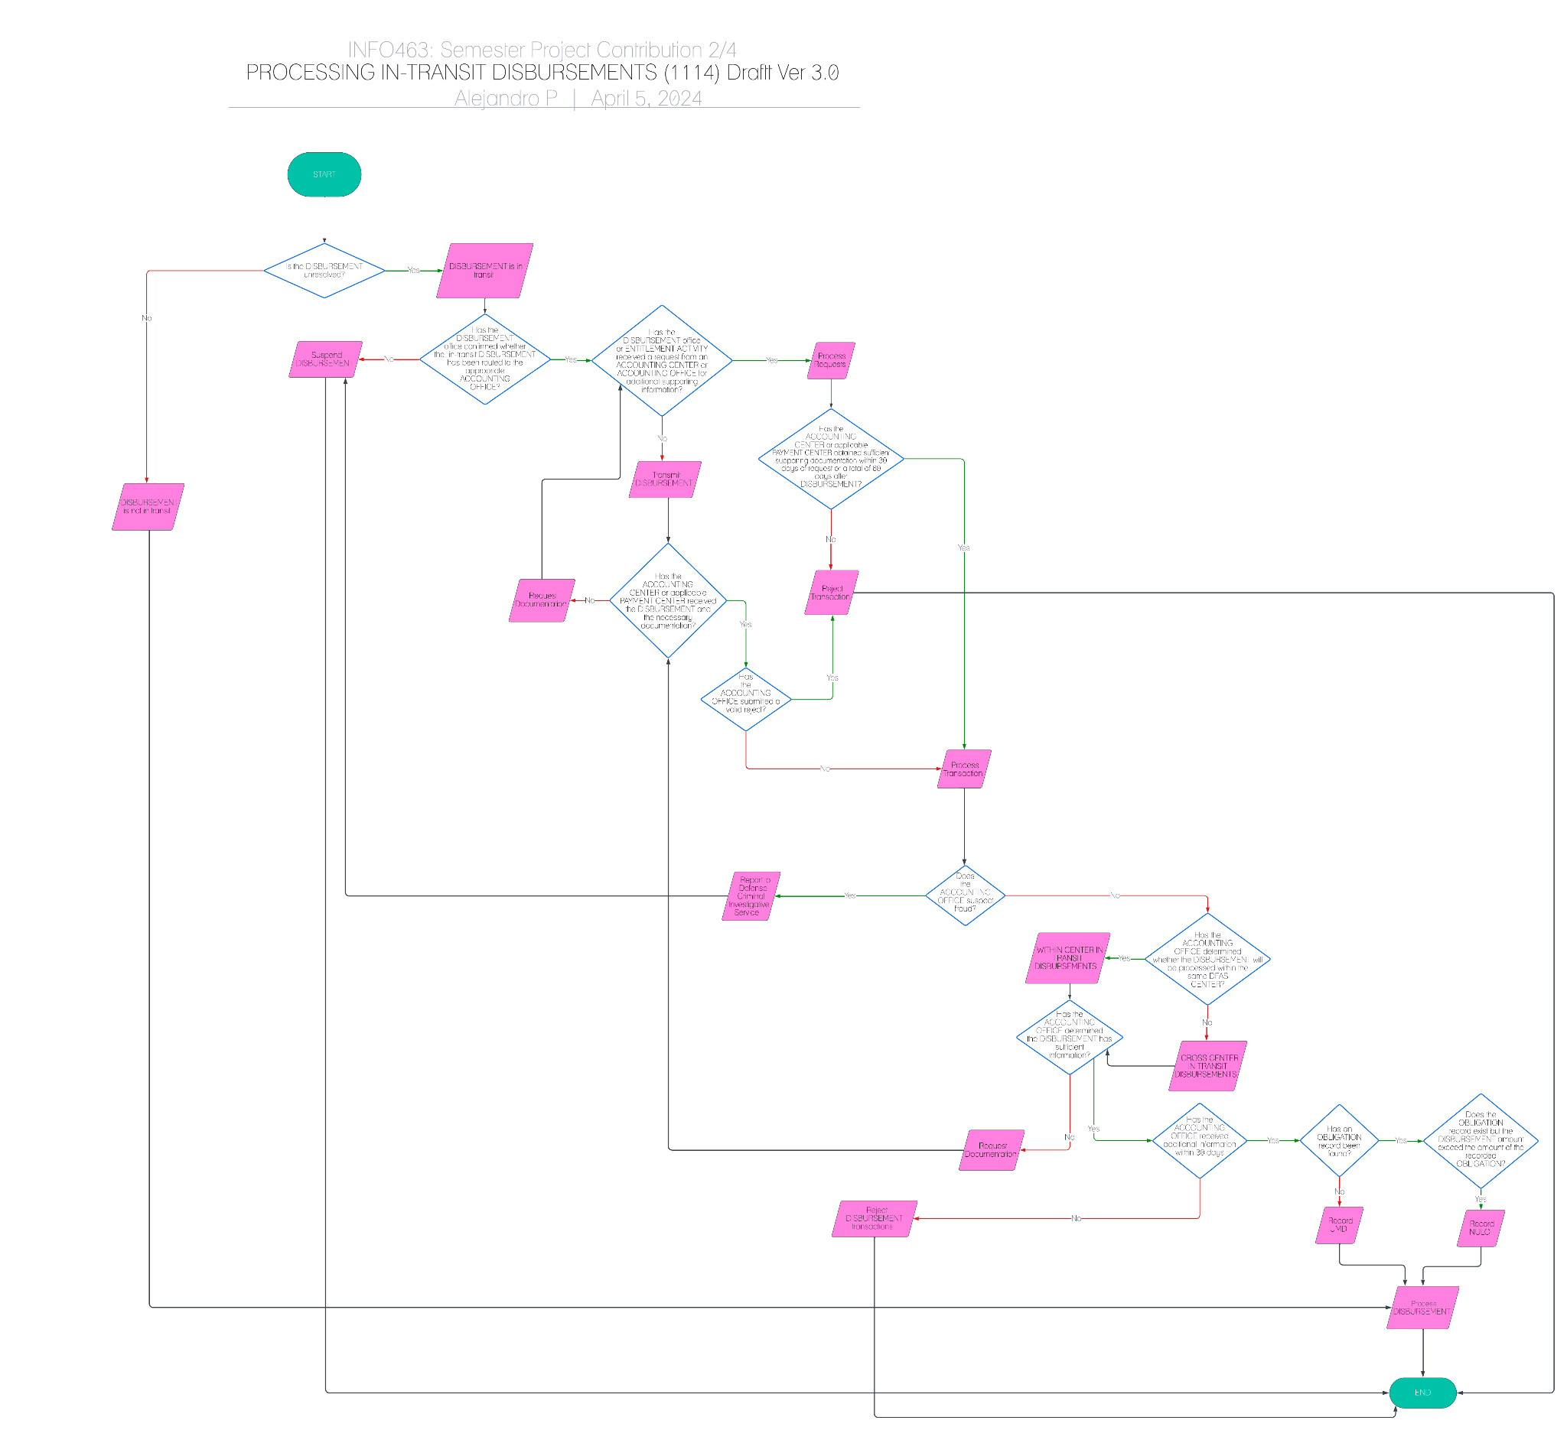

# Processing In Transit Disbursements Version 4

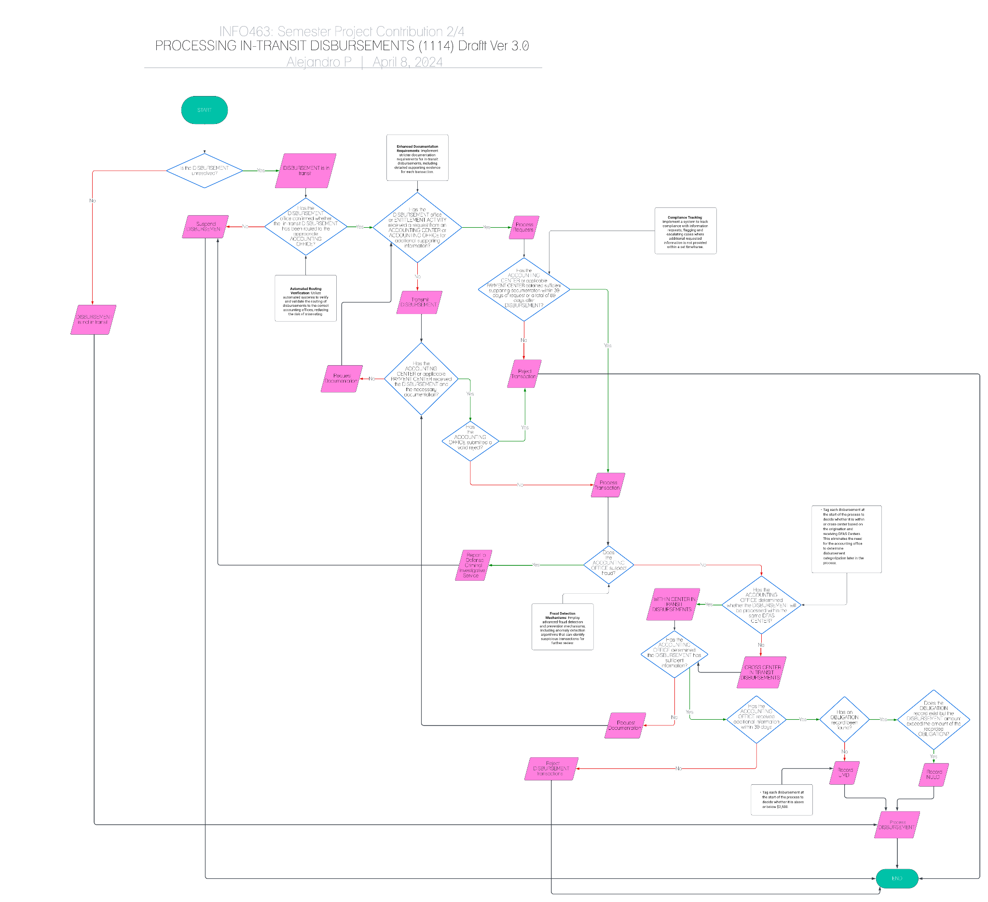

# Unified Control

# 

# Unified Control Version 2

# 

# Data Model

# 

# 

# 

# Identified Controls

* *Alejandro Porrata:*

**Controls Proposed:**

1. **Enhanced Documentation Requirements**: Implement stricter documentation requirements for in-transit disbursements, including detailed supporting evidence for each transaction.

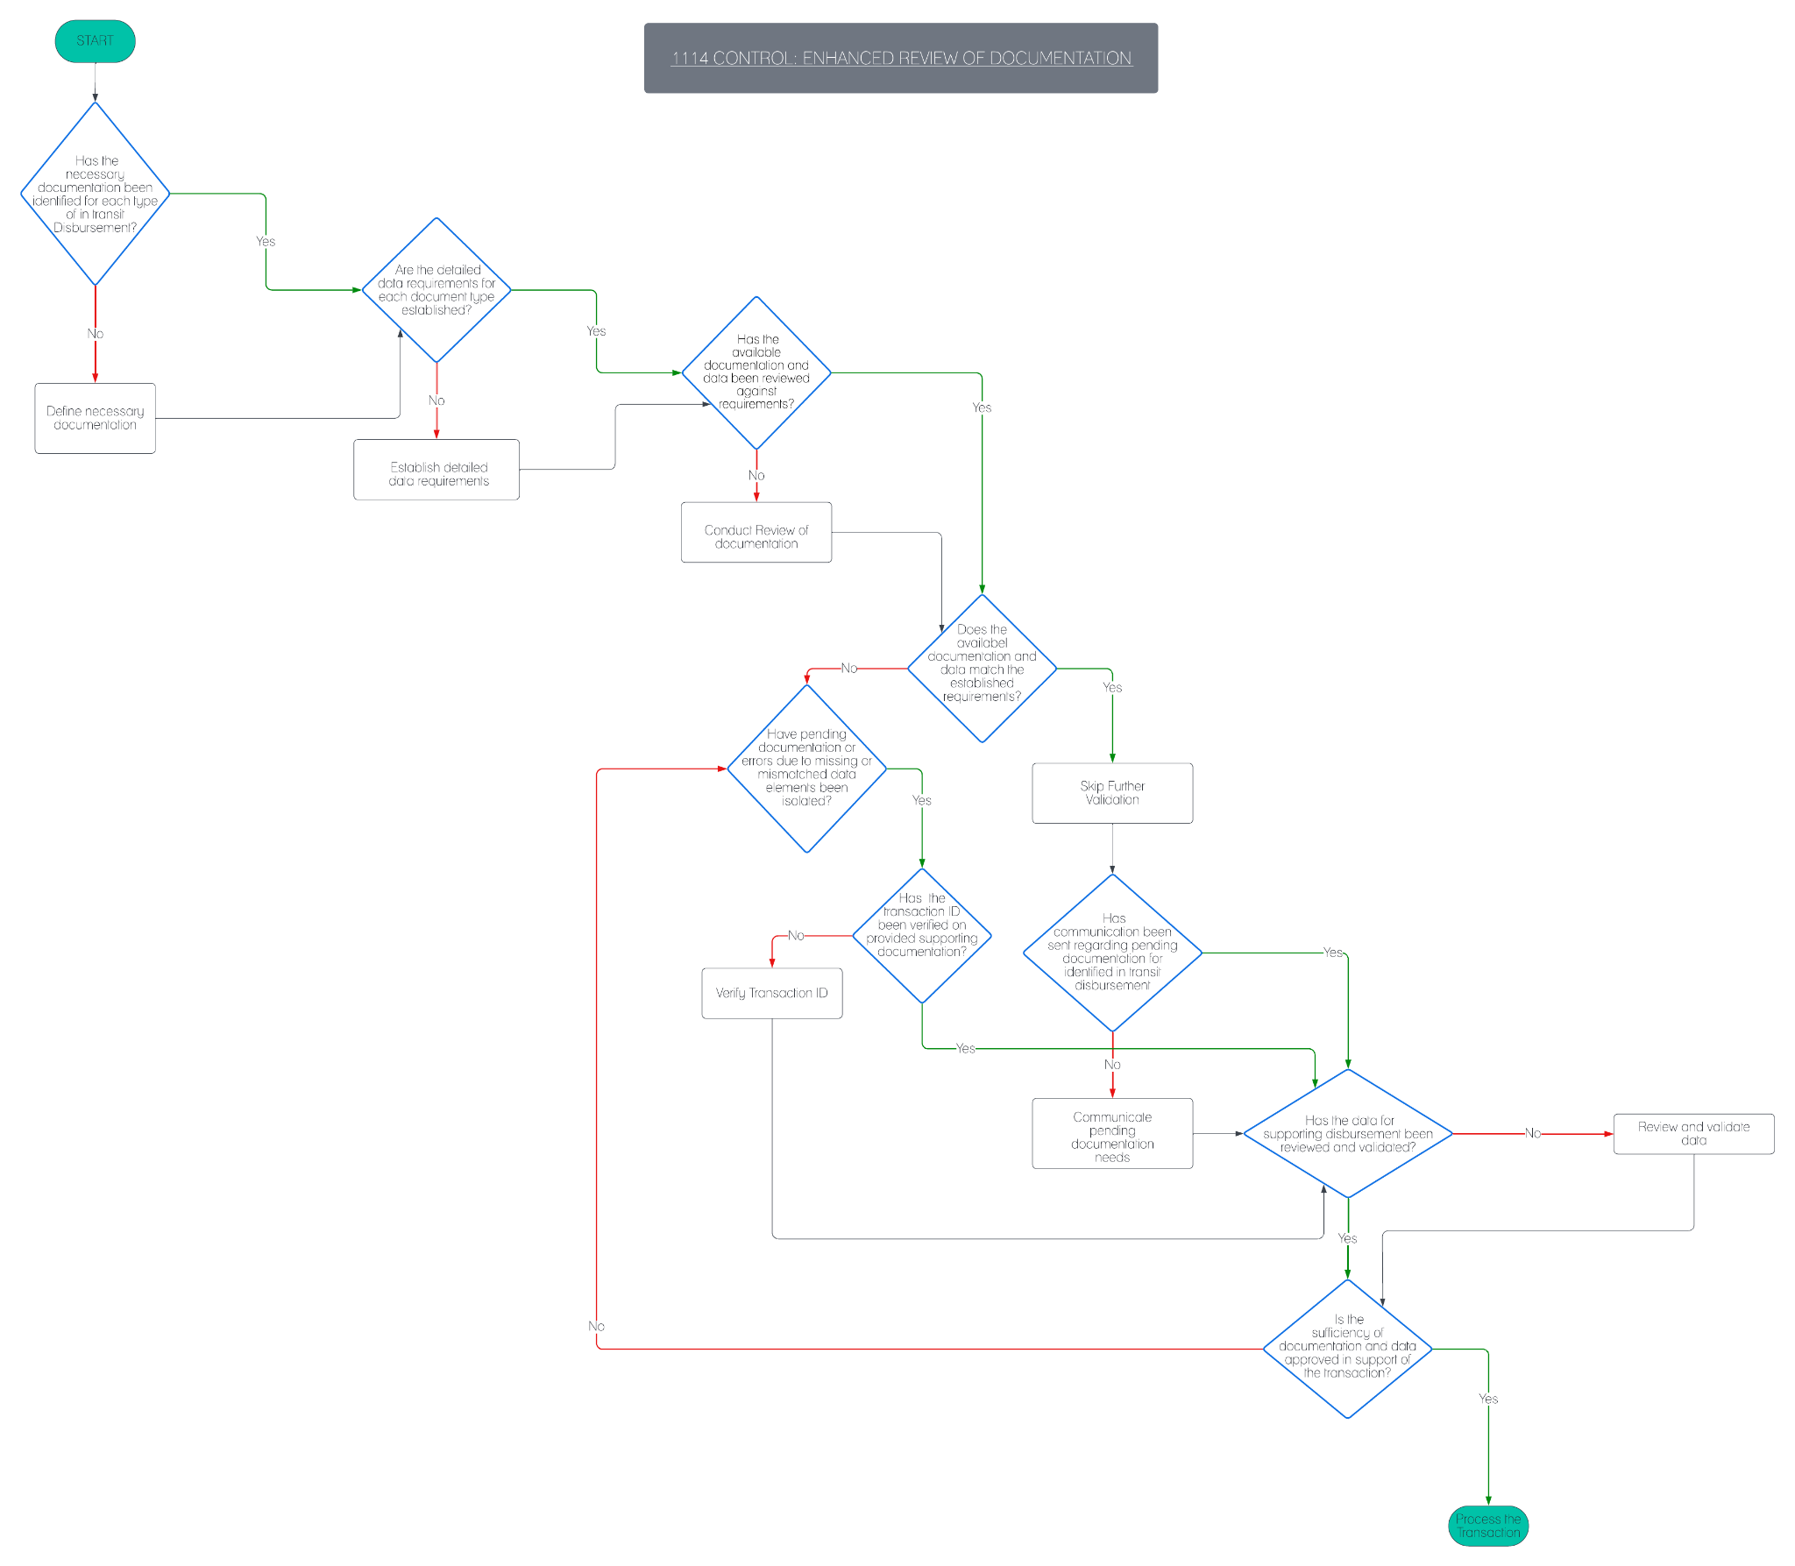

* *Jordan Richards:*
  + Tag each disbursement at the start of the process to decide whether it is within or cross-center based on the origination and receiving DFAS Centers. This eliminates the need for the accounting office to determine disbursement categorization later in the process.
  + 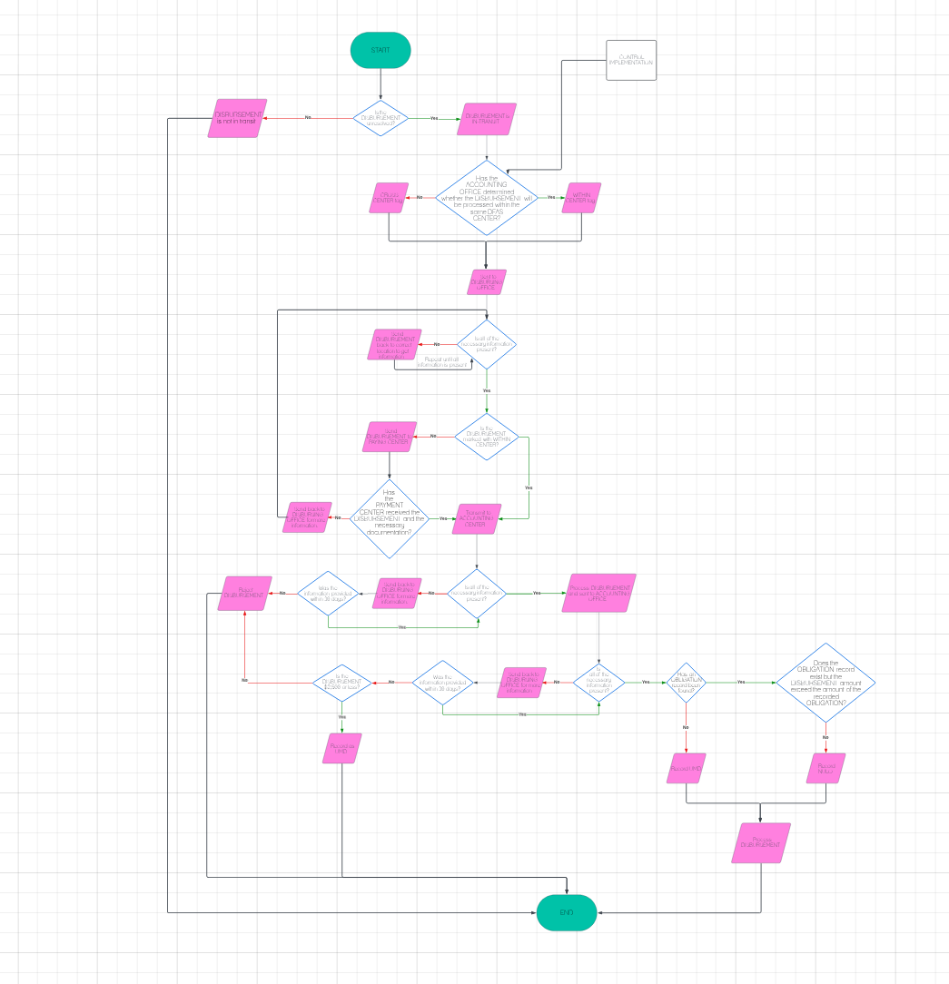
* *Nevin Wilson:* 
  + **Compliance Tracking**: Add tracking nodes after requests for additional information to monitor the responsiveness of different offices.

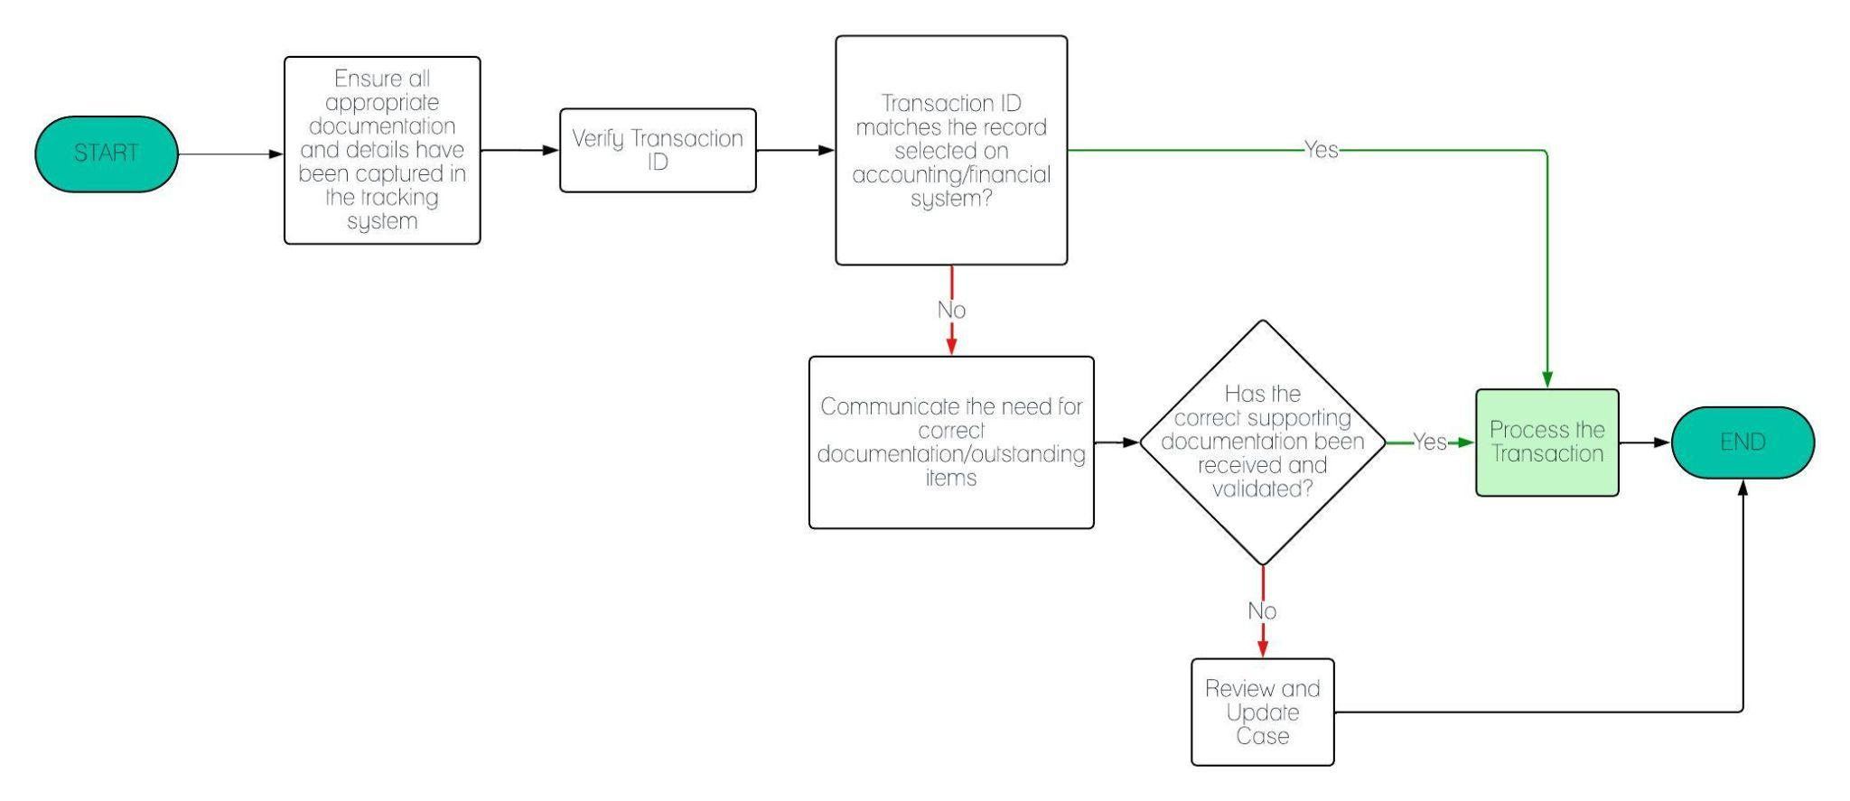

* *Natalie Ramdeo:*
  + **Data Encryption for Sensitive Information**: Encrypt sensitive financial information stored within the accounting system, such as payment authorization codes. This is to have a safeguard against unauthorized access or data breaches.
  + Make sure the Accounting Office has everything needed to transmit the necessary documentation.
    - An example could be “**Training on Document Handling**: Provide training to accounting staff on proper document handling procedures, including how to prepare, format, and transmit documentation securely while adhering to internal policies and external regulations.”.
  + **Dual Authorization**: For significant disbursements dual authorization before recording them in the accounting system to enhance accuracy and reduce the risk of unauthorized transactions.

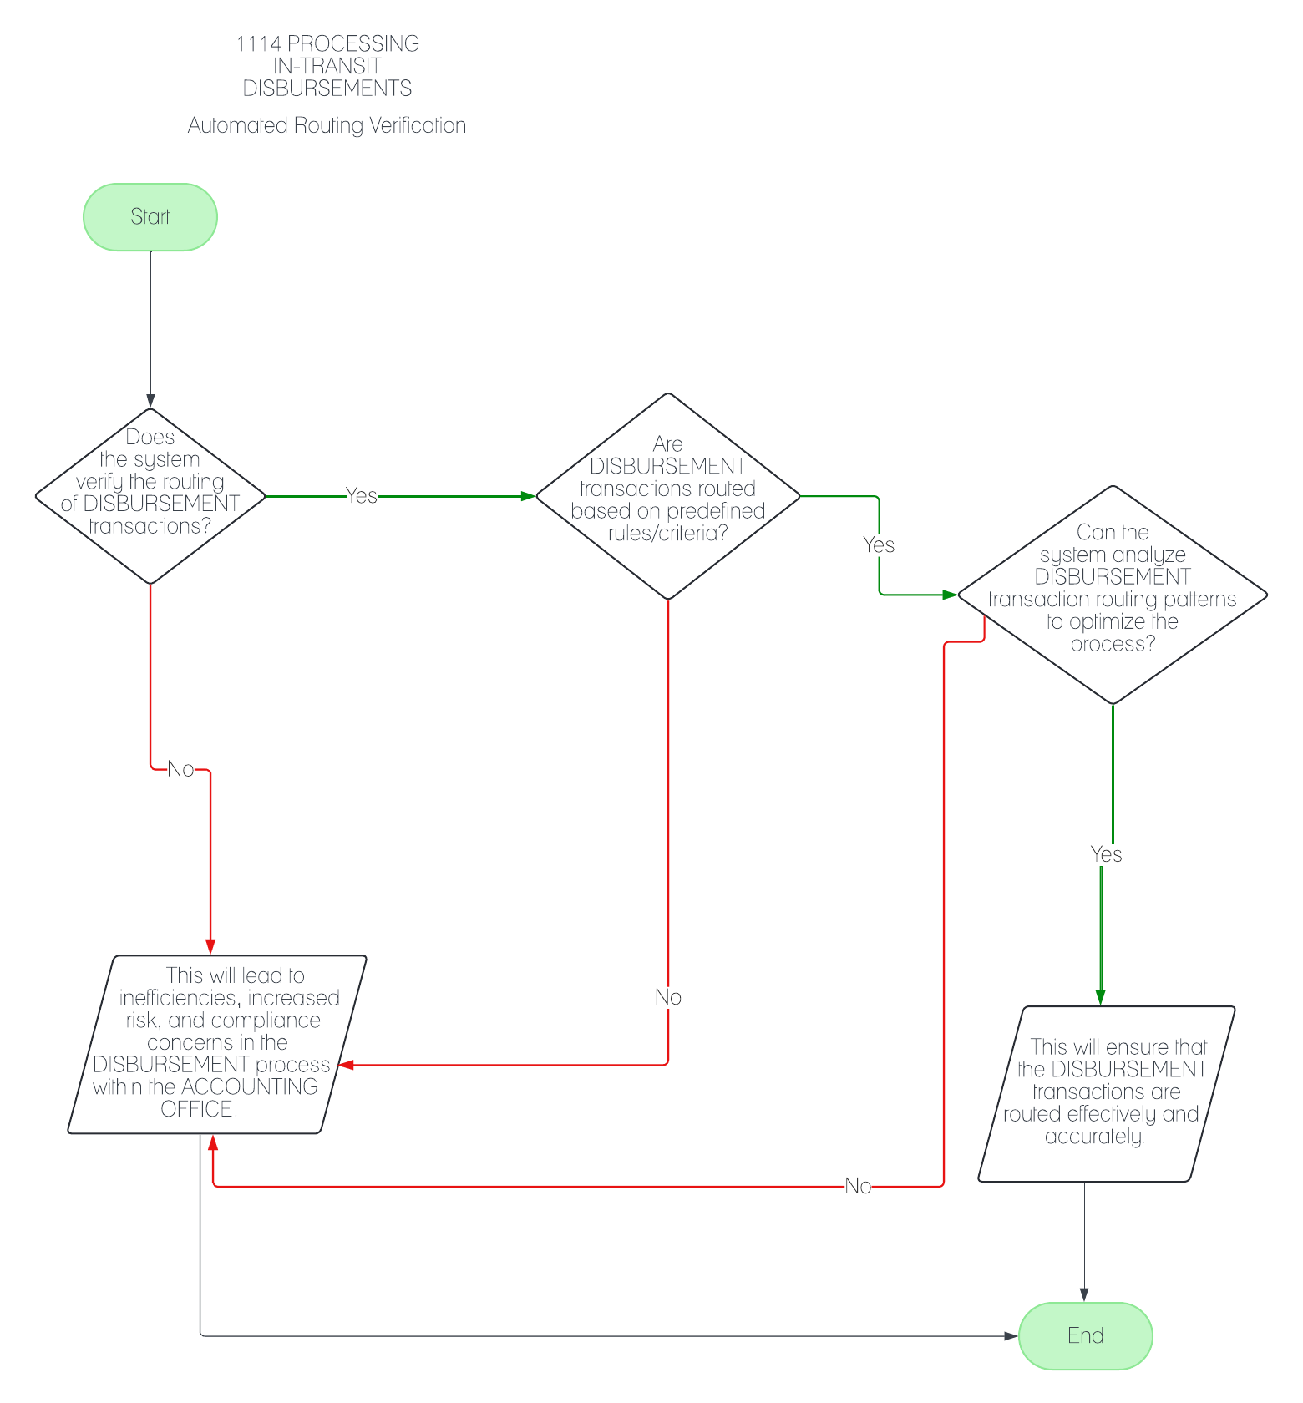

* *Samuel Kim* 
  + Implementing MFA, to create a level of security for users and protection on documentation.

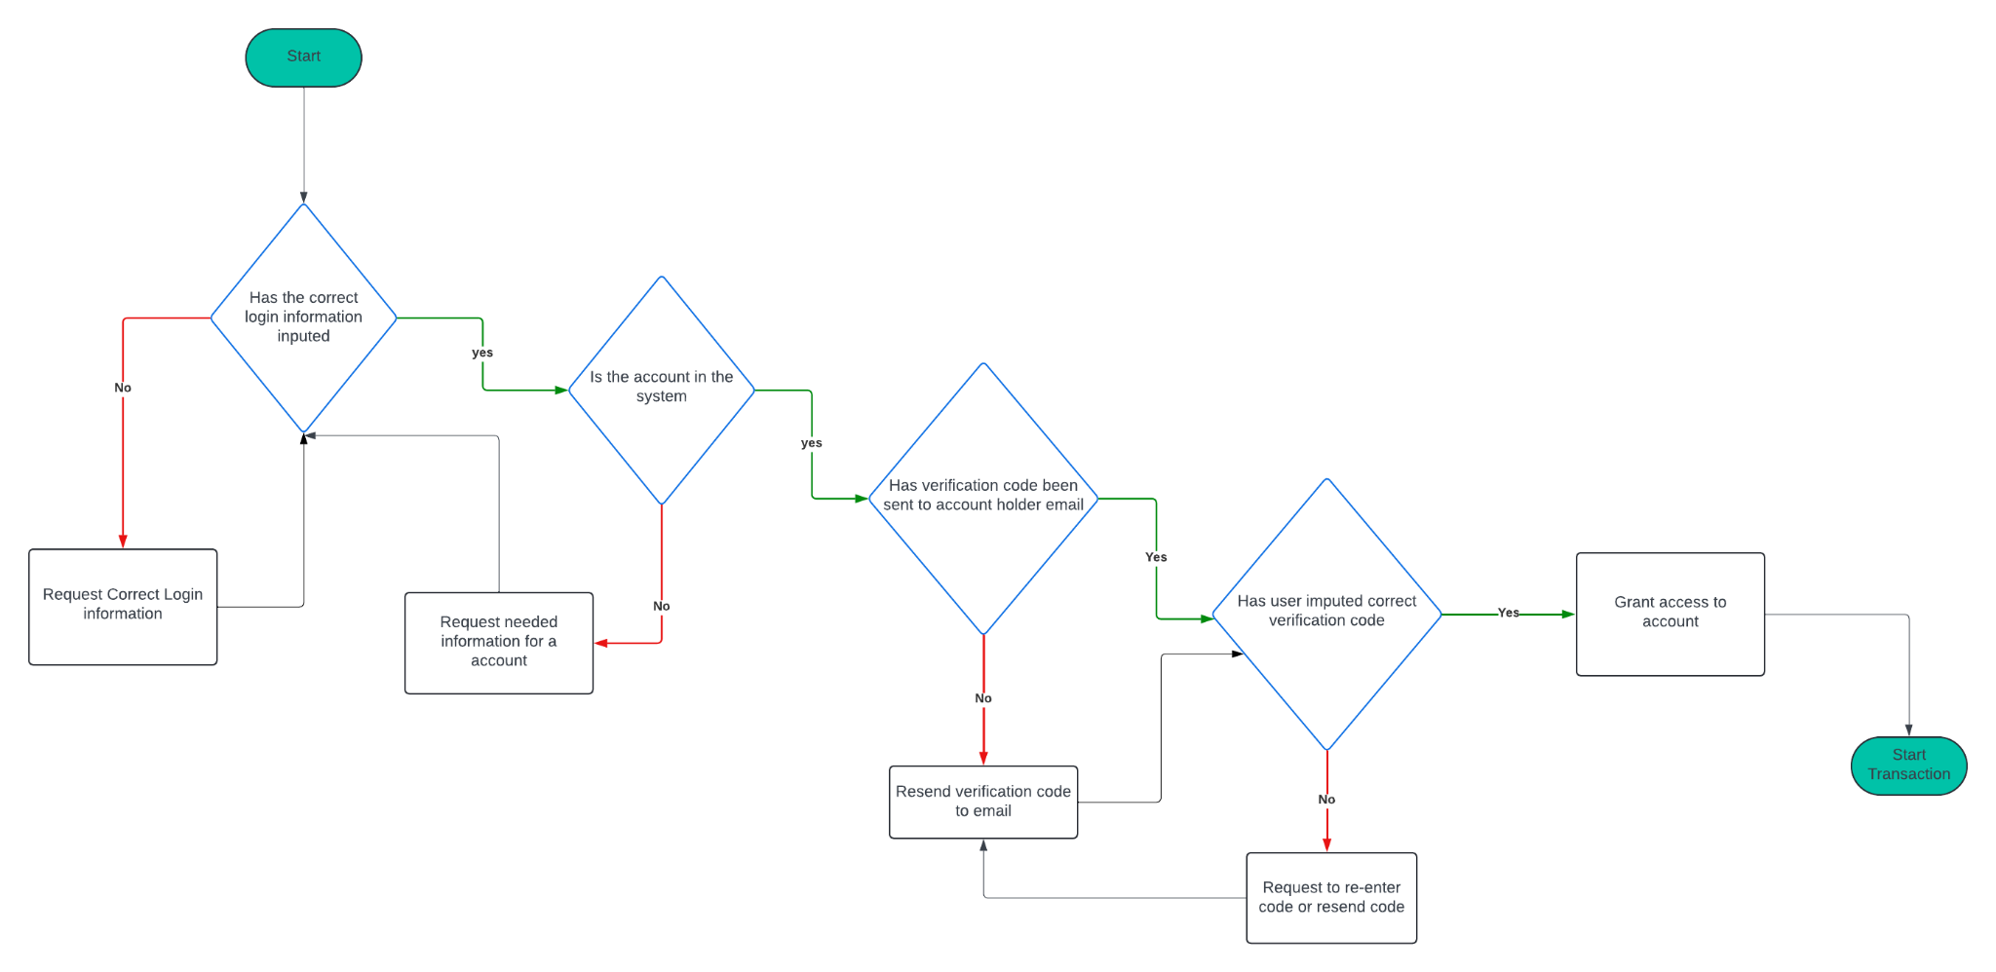

* *Asim Umar* 
  + To enhance the efficiency and accuracy of disbursement processes using UMD (Unmatched Disbursements) and NULO (Not Used Lose Obligation) controls,
  + implement rigorous documentation standards for all transactions, especially for disbursements under $2500 (UMD) and those exceeding recorded obligations (NULO).
  + Introduce an automated routing system to ensure correct routing to accounting offices and minimize errors. Use a tagging system at the start of the disbursement process to categorize transactions based on amount and center affiliation, aiding in rapid identification and processing.
  + Employ advanced fraud detection and compliance tracking to promptly address discrepancies and ensure all documentation requests are fulfilled.
  + Lastly, train accounting staff in effective document management to further streamline the process and reduce the need for additional information requests, thereby improving overall transaction handling and compliance.

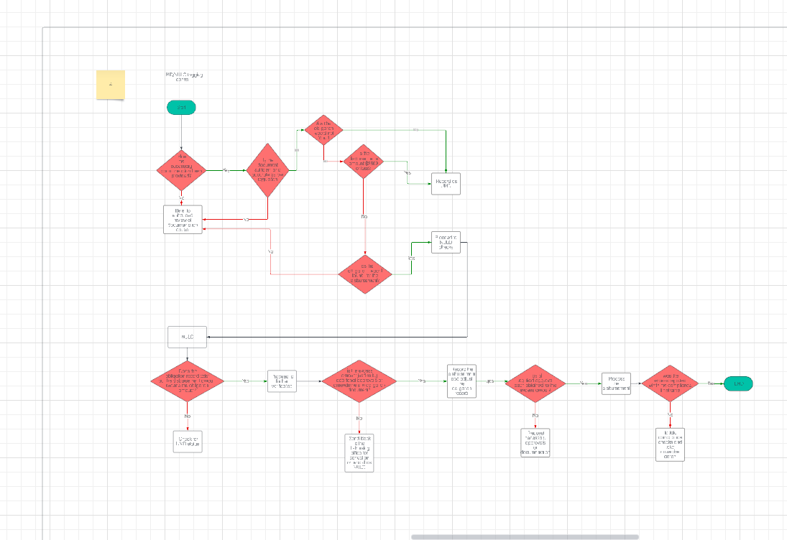

Url for the flow chart:

[https://lucid.app/lucidchart/66b4a801-a4d3-442d-8f54-1ec0a87f5812/edit?invitationId=inv_9fdc3a47-2153-4548-8954-2a13456d84f2&page=0_0#](https://lucid.app/lucidchart/66b4a801-a4d3-442d-8f54-1ec0a87f5812/edit?invitationId=inv_9fdc3a47-2153-4548-8954-2a13456d84f2&page=0_0)

* Jalen Coulton
  + **Fraud Detection Mechanisms**: Employ advanced fraud detection and prevention mechanisms, including anomaly detection algorithms that can identify suspicious transactions for further review.

